George Edward McDermott.
143 N. Huron Dr., Oxon, MD 20745
phone (301) 996-9577.
Email george2018@gmail.com
August 7, 2026

The U.S.A. Inc. , As. Named Defendants
It’s Office of The Solicitor General
Attention D. John Sauer Defendant
400 6th Street, NW Washington, DC 20001
by USPS CERT mail article # 9589-0710-5270-2912-6986-24
Dear John Sauer you are receiving this formal notice and certificate of service of six filings in the United States District Court for the District of Columbia, Court of Appeals the District of Columbia Court of Federal claims for the District of Columbia and Court of Appeals for the Federal Donald Circuit as the lead attorney for the corporation operating as the United States Inc. and its CEO Donald John Trump. Named defendants in these courts. As designated under Title 28 USC 3002 Section 15A states that the United States is a Federal Corporation and not a Government, including the Judiciary Procedural Section.
1. As the lead attorney for the Corporation whose agents have acted in bad faith and are warring against the Constitution and rule of law. And will not identify any of their elusive office employee identification numbers or alleged orders judgments and decrees as the attachments indicate I now ask if you could provide a written clarification. As to quality your clients and yourself are bound under the. December 9th 1945 International Organization Immunities Act relinquished every public office of the United States to the United Nations. And also, the following statutes laws,

22 CFR 92.12-92.31 FR Heading “Foreign Relationship” states that an oath is required to take office. Also
Title 8 USC 1481 stated once an oath of office is taken citizenship is relinquished, thus you become a foreign entity, agency, or state. That means every public office is a foreign state, including all political subdivisions. (i.e. every single court and that courts personnel are considered a separate foreign entity) 1603 –0.

2. Attorney D. John Sauer. As the leader attorney for the Corporation of the United States in in our United States Supreme Court, for 32 years I have been involved rights and liberties my properties by your client’s malfeasance, obstruction of justice, falsification of court documents, destruction of court documents which is necessitating this formal request of your office to identify your legal jurisdiction and authority in writing. You can see my previous formal request through reviewing documents of the cases you are now receiving available on pacer. You will see that at all
points in time. I have acted in the upmost adherence to the rule of law with clean hands and have been betrayed by hand my fellow Americans legal rights and access to our nation state court system. While being held as chattel against the nations now $40 trillion corporate debt which I never agreed to take on. Funding a corrupt corporate court system which does not follow the rule of law for our Constitution and Bill of Rights.
3. Solicitor Gen. your office and your clients need to come clean and produce documents as to your true corporate affiliation. As for 32 years plus not one of your clients’ agents is ever identified themselves or produce their oath of office in any court, these fictitious elusive offices are allegedly held after being signed and sealed secretly with the Department of Justice and the Department of State as well as national archives. Would you be so kind as to produce archived call numbers for the above statutes, the alleged corporate bylaws and amendments, and the agreement. All laws in this nation-state over to the United Nations. Under the December 9th 1945 International Organization Immunities Act. Which means I had not had an opportunity to object to this theft of protections rights and remedies of our organic Constitution and I was only six months old and could not be sold into slavery by now United States Inc.’s corporate government.
4. In closing as in the filings and certificate of service I will be hand delivering a copy of this formal request. To all 66 members of the House and Senate Judiciary committee. As corporate trustees over the rule’s statutes and regulations of this now nation-state Inc. which will be personally hand-delivered to the members offices on Capitol Hill and videotaped to be posted on https://www.youtube.com/@George4Justice. Along with 2000 other videos posted on my website chronicling the injustice betrayal and fraud being covered up by your clients against the organic citizens of the United States of America. Along with tens of thousands of court filings which your clients have never respond to in 32 years except with unsigned, unverifiable, fraudulent, falsified court documents disguised as orders judgments and decrees. I will wait your response and would be glad to meet with in your office with the reporter. Regarding this correspondence. God bless and have a great day. And pray for the victims who are represent who have lost billions of dollars.
Respectfully submitted
George Edward McDermott. All rights reserved UCC 10101, 102, 202, 306 – 08 15 USC §§ 7001 et seq. Title 8, 22, 1481 & 28 USC 1603 (a) (b) +1607 (a). As well as Title 28 USC 3002 Section 15A.
Attachments in support of correspondence. Date stamped copies. Motion filed with six court proceedings in the following cases. Each court was put on notice of the six-page filing which was copied to all other five courts USDC/DC/COA. CT case’s # 5411+25 – 5096 & US COA Federal Circuit case # 26 – 1526 & USDC/DC/ case # 1:25-2222, clerk refused to accept two other filings in violation of federal rules cases USDC/DC/# 1:98-cv-1235 TPJ and USCOFC case # 25 – 1398. A Continuing conspiracy in violation of the court rules exist by your clients. Every
IN THE CORPORATE US COURT OF APPEALS FEDERAL CIRCUIT
FOR THE DISTRICT OF COLUMBIA
This court’s case NUMBERS. 26-1526
And Cc. T0. related 25 – 5411 As well as the USCOFC case #25 – 1398 –MBH & US-US-COA-F/C-DC. # 26 – 1526 & US District Court case : 25- CV-2222 UNA. From case 98- 1235 TPJ.

George Edward McDermott.’ *
MD 20745 (301) 996- 9577 * *
Email @ georgemcdermott 2018@gmail.com *
proceeding under. 28 USC 1654 statute law. *
28 U.S.C. 1603 – 11. & FRCP Rule 3. Plaintiff/ * 28 § 2252 Jury Trial Demanded
Vs. *
The Corporate Entity’s Trading as * as well as rules 77, 78, 79, & 81 &
The United States Corporation. D&B # 52 – 194379 * FRE Rules 202 (a)(b)b)(c)(2)(d)(e),
and its CEO. Donald John Trump *b)(c)(2)(d)(e), FRE.R902, 1002, 201,
Defendants EIN numbers see at [ATT, – 1]
And its subsidiary Corporations *1005,1101 (a)(b), 1102, + 1103.
TRADING AS. SUBSIDIARY CORP * As All defendant are subject to FRCP Rule the U.S. Federal Bureau of * Rule the U.S. Federal Bureau of
The U.S. Department of Justice. * Investigations Inc.
The US Department of State * 26 (A) but every court has refused
the US Department of the Treasury * To disclose their corporate
And ABA and its affiliates/bar members * For the last 27 years while
The U.S. Department of Homeland Security Inc. * Treason against the Constitution. *As. Published/memorialized U.S.C.A
U.S. The office of Secretary of State Inc. offices. * THE published RULE OF LAW. And
- Named Appellees at Ei, * 22 CFR 92.12-92.31 as required ….??
APPELLANT’S NOTICE AND MOTION FOR THE COURT TO VACATE AND SET ASIDE ALL UNSIGNED ORDERS OF THIS COURT ALL JUDGMENTS AND DECREES OF THE JUDGES OF THIS COURT AND PURPORTED MANDATES AS WELL AS THE OTHER COURTS LISTED IN THE CAPTION FOR TREASON AGAINST THE CONSTITUTION IN FRAUD OF OFFICE BY CORPORATE COURT AGENTS WHO REFUSED TO IDENTIFY THEIR JURISDICTION AND OR AUTHORITY UNDER U. S. CODE TITLE -5- §§ 2902-06. AND US CRIMINAL CODE 18 USC 101.

Now comes appellant George make it through the motion practice of this court hereafter appellant filing this motion to vacate and set aside all motions judgments and decrees of this court and the related court listed above for treason against the Constitution in fraud on the court system consuming of government documents, falsification of court records, falsification of court dockets, obstruction of justice, and warring against the Constitution and rule of law as the case files in the above cases clearly make evident. And as this court has no jurisdiction or any of the other courts in, they have failed to provide repeatedly the oath of the United States Inc. Donald John Trump current CEO and all of its predecessors. Issuing void unsigned F-1office signed by the a.k.a. F/N.1
F/N.1 USDA title 28 § 2071. Concealment, removal, or mutilation generally. § 2072. False crop reports. § 2073. False entries and reports of moneys or securities § 2074. False weather report, § 2075. Officer failing to make returns or reports § 2076. Clerk of United States District Court.
president appointing said judges who signature must be on all appointments of corporate staff./ employees., Court personnel and judges.
1 Plaintiff is in receipt of the court’s latest nonconformity order and is returning the same to the court [ATT-1] as it has no force and effect and is a derivative of fraud on the court. Betraying their oath of office, and warring against the Constitution and rule of law to commit treason against the Constitution and Bill of Rights. This court is fully aware that is void under the void order judgment doctrine and has no force in order affect as to all previous orders of this court which the court has for 25+ years refused to produce any document showing jurisdiction and authority, any document producing valid oath of office signed by the CEO Donald John Trump or any other predecessor of the Corporation of the United States Inc. as a named defendant. His total use is less than that of a piece of used toilet paper the court can take that for what it means. See. [ATT-1].
All Courts participating in upholding illegal – void judgments
“Spitzberg v Notaro- Judge Gerald Rosenberg void. Based upon, Spitzberg respectfully requests that the Court set aside the Judgment entered on May 28th 2008 or in the alternative, Spitzberg moves this Court for a full evidentiary hearing for the purpose of arriving at a judgment that furthers Justice . Similarly, any other Court or entity insisting to uphold such an illegal order would be in violation of the US Constitution and therefore all officers of the court now involved with prosecuting this void order will be at risk for such censure , and may be subsequently arrested for these violations of law. Since a public servant must serve the law, and it was broken by the public servants in this case, they are acting as trespassers of the law,
2. Plaintiff realizes at this point after 32 years of illegal terrorism against he and his family that the corporate records of the United States Inc. and its corporate officers’ agents and assigns have no respect for the rule of law or our Constitution and Bill of Rights. So he has chosen to make this filing putting each judge in each court clerk and associate clerks on notice that they are now through their own actions and inactions engaged in the criminal conspiracy to destroy the plaintiff through any means possible using unsigned orders, void orders and void judgments, falsify court records documents, and falsified court documents to threaten and intimidate the plaintiff now reserves the right under article 10 of the one declaration of rights to hold each and every judge court clerk and court personnel as well as all sub agencies agents and assigns involved in this 32 year plus legal travesty of justice, again all orders judgments and decrees are void under statute law, F/N.2.
, F/N.2. “Any judge who does not comply with his oath to the Constitution of the United States, wars against that Constitution and engages in violation of the Supreme Law of the Land. If a judge does not fully comply with the Constitution, then his orders are void, in re Sawyer, 124 U.S. 200 (1888), he is without jurisdiction, and he/she has engaged in an act or acts of treason.”

3. This clerk’s office can and the other critics offices involved can keep sending out unverifiable falls for each court orders judgments and decrees. By USPS mail or by electronic means which they never validate or authenticate as required under 15 USC 7001 et seq. the court officers cannot claim ignorance of the law, lack of accountability to the Constitution of the United States of America, and adherence to the Bill of Rights and organic statute laws of this nation state. Not one of these entities is ever responded to any allegations set forth by plaintiff in the last 32 years except with unsigned unverifiable orders judgments and decrees leaving plaintiff/appellant wasn’t no alternative except dt to expose the blatant treasonous acts of this court and its clerks’ offices and agents .
“Fraud upon the court” makes void the orders and judgments of that court.
“It is also clear and well-settled Illinois law that any attempt to commit “fraud upon the court” vitiates the entire proceeding. The People of the State of Illinois v. Fred E. Sterling, 357 Ill. 354; 192 N.E. 229 (1934) (“The maxim that fraud vitiates every transaction into which it enters applies to judgments,
as well as to contracts and other transactions.”); Allen F. Moore v. Stanley F. Sievers, 336 Ill. 316; 168 N.E. 259 (1929) (“The maxim that fraud vitiates every transaction into which it enters …”); In re Village of Willow brook, 37 Ill.App.2d 393 (1962) (“It is axiomatic that fraud vitiates everything.”); Dunham v. Dunham, 57 Ilapak. 475 (1894), affirmed 162 Ill. 589 (1896); Skelly Oil Co. v. Universal Oil Products Co., 338 Ill. App. 79, 86 N.E.2d 875, 883-4 (1949); Thomas Stasel v. The American Home Security Corporation, 362 Ill. 350; 199 N.E. 798 (1935). Under Illinois and Federal law, when any officer of the court has committed “fraud upon the court”, the orders and judgment of that court are void, of no legal force or effect.”

4. Plaintiff/Appellant. Is now This filing this notice officially to the court even though it is unnecessary because every judge every attorney. Every clerk of the court is fully aware that a void order, especially unsigned void orders which court clerks refuse to authenticate cannot be authenticated or validated need not be appealed as cited in. Elliot v. Piersol, 1 Pet. 328, 340, 26 U.S. 328, 340 (1828): with the full knowledge that actions are in violation of the employment contract and required oath of office and judicial bonds. With full anticipation. This clerks’ offices will continue this pattern and practice with the other officers within the judicial system of the corporate agents and agencies of the United States defendants listed in the above caption. Named in the complaint. Plaintiff now submits into the record. F/N.3 knowing you caption the court will attempt to deny filing of this motion paper based on yet another unsigned order, which will constitute another federal crime and act of treason F/N.3
F/N.3. § 2071. Concealment, removal, or mutilation generally. § 2072. False crop reports. § 2073. False entries and reports of moneys or securities § 2074. False weather report, § 2075. Officer failing to make returns or reports § 2076. Clerk of United States District Court. § 2071. Concealment, removal, or mutilation generally. § 2072. False crop reports. § 2073. False entries and reports of moneys or securities § 2074. False weather report, § 2075. Officer failing to make returns or reports § 2076. Clerk of United States District Court.
This where the statute is vague, People v. Williams, 638 N.E. 2d 207 (1st Dist. (1994).

In conclusion
5. Plaintiffs/Appellant//petitioner now moves that the clerks of this court as well as the clerks of the following court cases in the USDC-DC/CT 1:98-CV-1235-TPJ and all subsequent cases related to those proceedings dismissed with forged unsigned orders falsified court documents court dockets and judgments now being appealed in the shame of sham unsigned July 9, 2026 order by this court all records be preserved including appeals to the case # in this court # 25 – 5096, 25 – 5411 from USDC – DC – CT case #appealed to the US Court of Federal claims case # also allegedly being dismissed with unsigned orders 25 – 1398 which was also appealed to the United States Court of Appeals for the Federal Circuit case # 26 – 1526 emanating from USDC – DC – CT 1: 25 – CV – 02222. All cases which no judgment is ever produced their oath of office and no clerk has ever produced their oath of office for bonds is required making all their judgments and orders void plaintiff/appellant/petitioner now submits 23 statutory reasons these proceedings are void. F/N.4.
F/N.4. Subject matter failings are usually void due to the following statute laws: (1), No petition in the record of the case, Brown v. VanKeuren, 340 Ill. 118,122 (1930). (2), Defective petition filed, Same case as above. (3), Fraud committed in the procurement of jurisdiction, Fredman Brothers Furniture v. Dept. of Revenue, 109 Ill. 2d 202, 486 N.E. 2d 893(1985) (4),Fraud upon the court, In re Village of Willowbrook, 37 Ill, App. 3d 393(1962) (5), a judge does not follow statutory procedure, Armstrong v. Obucino, 300 Ill 140, 143 (1921) (6),Unlawful activity of a judge, Code of Judicial Conduct.(7),Violation of due process, Johnson v. Zerbst, 304 U.S. 458, 58 S.Ct. 1019(193 ;Pure Oil Co. v. City of Northlake, 10 Ill.2d 241, 245, 140 N.E. 2d 289 (1956);Hallberg v Goldblatt Bros., 363 Ill 25 (1936), (8), If the court exceeded its statutory authority. Rosenstiel v. Rosenstiel, 278 F. Supp. 794 (S.D.N.Y. 1967)
(9) any acts in violation of 11 U.S.C. 362(a),IN re Garcia, 109 B.R. 335 (N.D> Illinois, 1989). (10) Where no justiciable issue is presented to the court through proper pleadings, Ligon v. Williams, 264 Ill. App 3d 701, 637 N.E. 2d 633 (1st Dist. 1994) (11)Where a complaint states no cognizable cause of action against that party, Charles v. Gore, 248 Ill App. 3d 441, 618 N.E. 2d 554 (1st. Dist. 1993) (12) where any litigant was represented before a court by a person/law firm that is prohibited by law to practice law in that jurisdiction. (13) When the judge is involved in a scheme of bribery (the Aleman cases, Bracey v Warden, U.S. Supreme Court No. 96-6133(June 9, 1997)
(14) Where a summons was not properly issued. (15) Where service of process was not made pursuant to statute and Supreme Court Rules, Janove v. Bacon, 6 Ill. 2d 245, 249, 218 N.E. 2d 706, 708 (1953) (16) when the rules of the Circuit court are not complied with. (17) when the local rules of the special court are not complied with. (One Where the judge does not act impartially, Bracey v. Warden, U.S. Supreme Court No. 96-6133(June 9, 1997) (19) where the statute is vague, People v. Williams, 638 N.E. 2d 207 (1st Dist. (1994) (20) when proper notice is not given to all parties by the movant, Wilson v. Moore, 13 Ill. App. 3d 632, 301 N.E. 2d 39 (1st Dist. (1973) (21) where an order/judgment is based on a void order/judgment, Austin v. Smith, 312 F 2d 337, 343(1962);English v. English, 72 Ill. App. 3d 736, 393 N.E. 2d 18 (1st Dist. 1979) or (22) where the public policy of the State of Illinois is violated, Martin-Tregona v Roderick, 29 Ill. App. 3d 553, 331 N.E. 2d 100 (1st Dist. 1975)
And another that can and should be checked on is does the judge have a copy of his oath of office on file in his chambers? If not, he is not a judge and yes, you can go into his office and demand to see a copy of his oath of office at any time. The laws covering judges and other public officials are to be found at 5 U.S.C. 3331, 28 U.S.C. 543 and 5 U.S.C. 1983 and if the judge has not complied with all of those provisions, he is not a judge but a trespasser upon the court. If he is proven a trespasser upon the court (upon the law) not one of his judgments, pronouncements or orders are valid. All are null and void. (Hundreds of requests denied why )

In summation.
6. Plaintiff/appellant/petitioner having duly reported fraud on the court, by the court officers under the direction of the defendant corporation and its CEO and Board of Directors for the last 32 years is entitled to be compensated for losses incurred by him and his other victims under article 10 of the Maryland declaration of rights as well as US criminal code title 18 U.S. Code Title 18 PART I CHAPTER 109A. § 2248 (a)-(c). This court in its clerks’ offices are fully aware of cordial duty. To hold corporate defendants liable for restitution to the plaintiff/appellant/petitioner for the defendants agents willful maltreatment of victims’ rights outline under U.S. Code Title 18 PART II CHAPTER 232 § 3663A, this latest series of orders all constitute fraud on the court. An assault on the Constitution of this nation state. Which will and must be reported to all members of the US House Judiciary Committee and Senate Judiciary Committee once again as the trustees of the offending corporation and its employees’ managers and assigns. Engaged in malfeasance of office falsification court records and government documents. Destruction of court records enjoy DNA RICO conspiracy to violate the civil legal rights of plaintiff/appellant/petitioner by hundreds of corporate government agents named in the original complaint. A video record of this maltreatment is posted secret justice.com and at YouTube George4justice 2000+ videos total which the court can take judicial notice of. https://www.youtube.com/@George4Justice.
Relief sought vacate and set aside all judgments orders and decrees the court will not authenticate or validate or provide the elusive offices of alleged judicial officers and purported signers.
Respectfully submitted

George McDermott. All rights reserved UCC 1-101, 201, 306-308 & 15 U.S.C.A. 7-1001 et seq.
Attachment and supportive motion [ATT-1].
Certificate of service. The office of solicitor Gen. Attention D. John Sauer 400 6th Street, NW Washington, DC 20001 by USPS CERT mail article # 9589-0710-5270-2912-6986-24 As no attorney for the defendants have ever answered any pleadings on behalf of USA Inc. and have therefore waived all defenses. With additional copies to be hand-delivered to all members of the US House and Senate Judiciary committee members by hand after date stamping into the court record. By George McDermott on08/07/2026_______

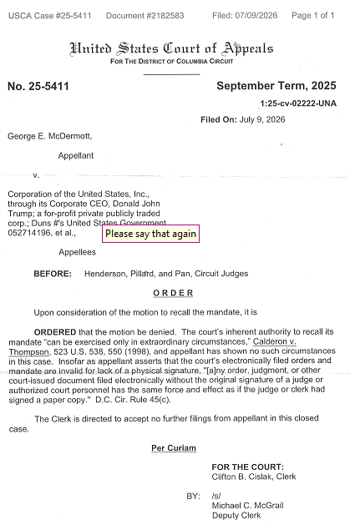

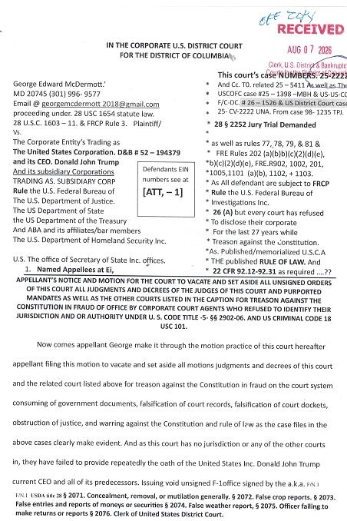
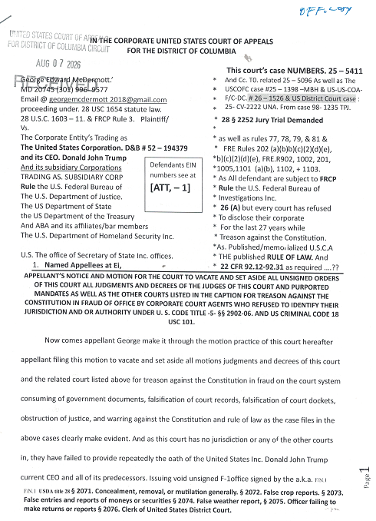
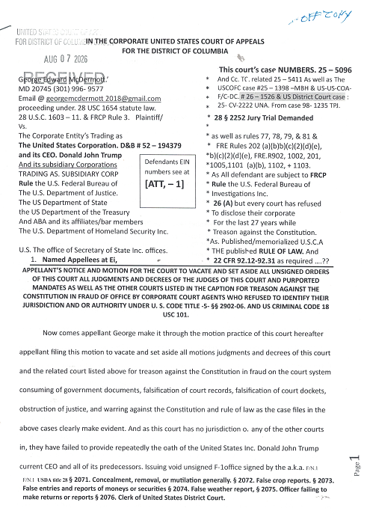

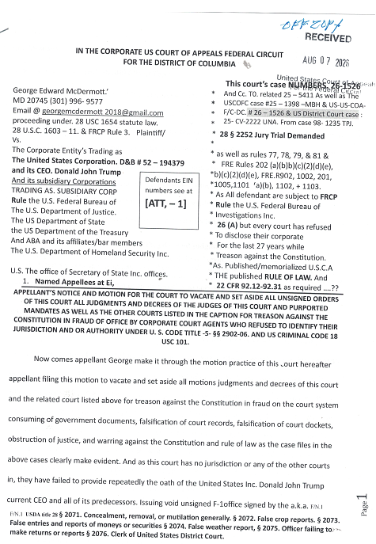
Solicitor Gen. D. John Sauer.. These two cases the clerk of the court refused to accept the filings based on fraudulent unsigned orders dismissing cases as part of a 32 year cover beginning in 1994 and continuing through the date of this filing and notice. I had respectfully requested the court officers to provide their names and court ID numbers so I could report these misconducts to your office and to the house and Senate members of the judiciary. In both cases they refused and the Court of Federal claims this was witnessed by US Marshal and recorded on the courthouse video in the lobby, review of the video will show that I in no way acted in bad faith or threatened any court officer or agent or assign. I believe you should look into this matter as millions of Americans are deprived of the rights and liberties by the illegal actions of clerks the court subverting their oath of office and rules of the court. Which is a crime outlined in the motion papers filed.. Which you now have copies.
Furthermore, 2026 general election as a candidate for the United States Congress Maryland’s fourth congressional district as a Republican let them put through to the general election I need the questions posed in paragraph one and two of this correspondence. I will not relinquish my citizenship in the United States of America to become an agent of the corporations you are defending yet know government authority will produce the proofs that the statute laws have been amended and replaced. So, I must assume they are still the rule of law.

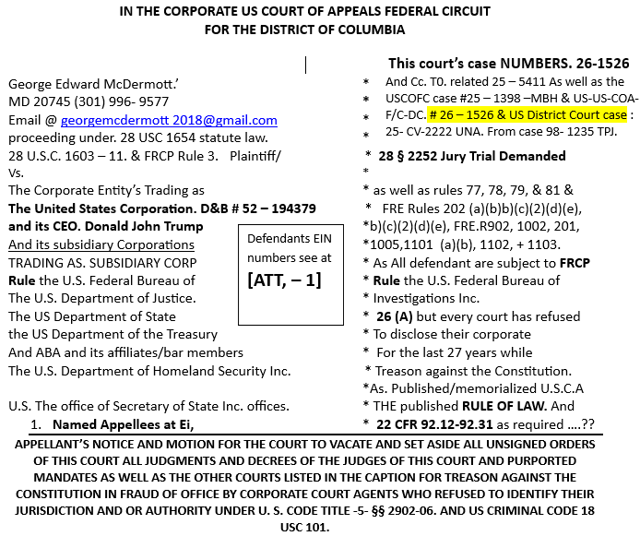 | 