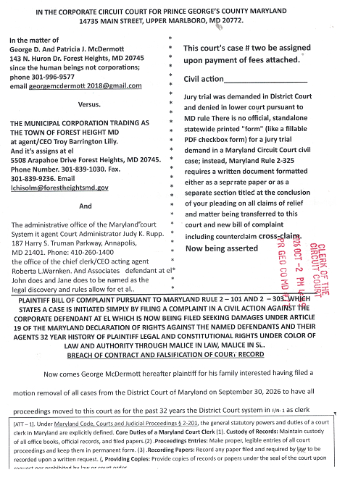
failed to provide honest services required under law and statute, [ATT – 1] which the plaintiff
has outlined in his motion and reasons for removal to prevent further abuse of process by the District Court clerk’s office is officer’s agents and assigns and exercising his right there in to file this bill of complaint and demand that the court judicial notice of its records dating back to 1995 case’s # more particularly the ruling of the court in case CAL 95 – 13288 in this court which demoted plaintiff to a second-class citizen. An overturned jury verdict put into the record and recorded in appealed and affirmed in favor of the plaintiff in this case only to be overturned upon return to this court which led to this court allowing Mafia agents to illegally encumber plaintiff’s property for 32 years and operated businesses various false corporate entities doing severe harm to the plaintiff’s denying all relief to victim/plaintiff as order states.
Emphasis supplied there can be no doubt that the court considers the plaintiff to be a second-class citizen, the court has covered up the malicious maltreatment of plaintiff in the past and will most likely continue the pattern and practice. Which now can be documented in state and federal court records" and courts.
Still plaintiff must abide by the law follow liberal and once again seek justice in this court with the tens of millions of dollars of losses by himself and his family and partners
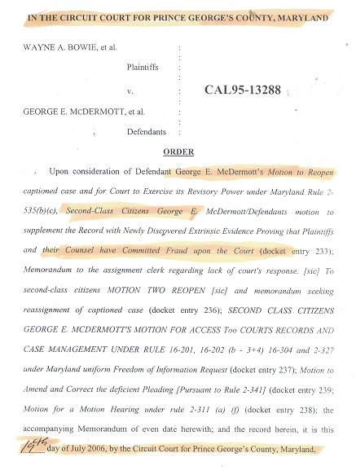

PLAINTIFF’S JURISDICTIONAL DESIGNATION OF PARTIES, JURISDICTIONAL STATEMENTS, NUMBERED FACTUAL ALLEGATIONS, SUPPORTED BY COURTS STATUTORY LAW
1. Plaintiff alleges that the defendants at el all had a duty to prevent these ongoing atrocities of law continue through plaintiff/alleged criminal defendants most recent filing in the District Court clerk’s office Hyattsville Maryland September 29, 2026 or the clerk of the court refused to produce copies of judicial oath of office of the clerk’s defendant had interaction with the alleged judicial officers of that court under 28 USC 1603 as corporate agents including alleged clerk Raymond Jacobs and supervising clerks refuse to accept payment for removal of this action from the District Court to this court, stating one Mrs. Harrison claims which courthouse security video should affirm. The court surveillance will verify at no time did plaintiff act in bad faith. And repeatedly stated that District Court could not be trusted any further a video record was made after leaving the court to memorialize for appeal the court actions. Posted at George4justice on YouTube see video clip along with hundreds of others @https://www.youtube.com/watch?v=cz_99-afzs8 .
2. Plaintiff has found it necessary to videotape all actions with court. Due to courts continuing misconduct in support of Mafia agents Wayne A. Bowie and Peter Parker Esq. in the theft of millions of dollars of their assets of the plaintiff using forged falsified [ATT – 2]. Documents falsified judgment liens, falsified titles of ownership, which three juries of this court have already found to be fraudulent. The above-captioned case CAL – 95 – 00940, CAL – 95 – 13288, CAL – 95 – 26059,. And CAL – 97 – 08728. All jury verdicts for the defendant overturned insider officer of this court Thomas P Smith brother-in-law of the Mafia control agent Peter Parker Esq. after appeal affirmed Mafia agents took these cases on appeal which is a matter of record. [FN– 2].
3. Plaintiff alleges that the clerk of these court agents have acted Malun se / mala prohibited conduct through their current and past repeated failures to perform honest services to their employers by allowing falsification of court records, court’s dockets, court video transcription, just as the District Court is already denied plaintiff’s demand for jury trial and attempted to deny motion of removal to this court. Plaintiff respectfully request that this new bill of complaint/ court case MUST not be assigned to any Judge in this court who had any affiliation with any case involving George Mc Dermott et al.
[FN –2]. Article 19 of the Maryland Declaration of Rights guarantees that every person who suffers an injury to their person or property has a right to a legal remedy, justice without sale or denial, and a speedy resolution according to the law of the land. "? This court continue to deny plaintiff at el. Constitutional right to a full fare on this proceeding which has been denied for more than 30 years to cover up this conduct of bonded court officers. Clerks of the court warning against the Constitution/rule of law.

[ATT – 2].. . Under Article 23 of the Maryland Declaration of Rights, the right of a trial by jury is "inviolably preserved," meaning that valid jury verdicts cannot be casually set aside or overturned by a judge. However, the declaration does not create an absolute bar against overturning a verdict; rather, it establishes strict constitutional boundaries for when a court can intervene. Former judge Thomas P Smith and others of this court knew they were violating plaintiffs constitutional rights and acted in mala prohibitive fashion anyway. It's
3. Plaintiff alleges that this court by allowing it agents to designate plaintiff as a second-class citizen. Has placed plaintiffs at all . Given that the defendant corporations’ agents in the District Court below as of 09/30/2026. Refused to accept payment for motion of removal from the lower court to this court, court WOULD not produce the oath of office or required bonds, and repeatedly made false statements as to jurisdiction and authority, docket entries cases evidencing that the scheduling notices have been sent out properly saying that no dockets of these types of cases are available as the court does not keep dockets on municipal actions against citizens has caused plaintiff’s extreme emotional financial, emotional, losses of the past 23 years in the amount of tens of millions of dollars.
4. Plaintiff asserts this is been a pattern and practice from the last 30+ years beginning in 1995 and continuing to present yet the plaintiff corporate agents in lower courts. In this court clerk’s offices have an are currently. Attempting to inflict further financial losses on the defendants/plaintiffs in this case. At the same time alleging the court has no jurisdiction over the municipal defendants the court is only allowing the use of its facilities to facilitate corporate municipalities agents and assigns collection efforts or citations. For the benefit of third-party corporate nongovernment entities. Okay All Punitive compensatory, and exemplary damages the defendants’ agents have caused plaintiff over the last 32 years plus. And that any judge assigned this case MUST produce his of the law office, and his judicial bond/corporate affiliation under citing MD Constitution, Art. 1, § 9 yet all points are used to produce fees of office why. [FN –3].
[FN –3]. MD Constitution, MD CONST Art. 1, § 9 clearly states open "Every person elected, or appointed, to any office of profit or trust, under this Constitution, or under the Laws, made pursuant thereto, shall, before he enters upon the duties of such office, take and subscribe the following oath, or affirmation: I, .........., do swear, (or affirm, as the case may be,) that I will support the Constitution of the United States; and that I will be faithful and bear true allegiance to the State of Maryland, and support the Constitution and Laws thereof; and that I will, to the best of my skill and judgment, diligently and faithfully, without partiality or prejudice, execute the office of .........., according to the Constitution and Laws of this State, (and, if a Governor, Senator, Member of the House of Delegates, or Judge,)

5. This court has jurisdiction and authority as well as a duty to accept this filing as original proceedings which led to the 30 years of deprivation of legal rights, the direct causation and result of the malicious, mala in se and the deliberate. Consequential damages causing malicious injury to the plaintiff’s this Court’s prior actions and ongoing actions and those of the defendant corporations refused to identify the corporate affiliation, produce any legal discovery, as the court has decided below plaintiff is not entitled to a jury trial, legal discovery, interrogatories or to face the defendants’ agents and in open court before a jury of his peers. As law requires citations clearly state that on the order of 06/10/2026 on all citations status notice and I quote. (“Status notice – criminal/traffic”) yet the courts of the court will not produce their oath of office, dockets of the various cases alleged, the judges alleged judicial oath of office of pattern and practices that prompted this court and others for 32 years that must stop. See [ATT-1]. [FN –3]. Plaintiff reserves the right to incorporate by reference all previous court filings in this court, the District Court of Maryland, and all federal courts especially relating to. USDC – DC – CT court cases 1: 98-CV-1235 TPJ as well as 1: 25-CV-2222 UNA, all related appeals in the federal court system including District Court’s, Court of Appeal, courts are federal claims, Court of Appeal for the Federal Circuit, and the United States Supreme Court. All news agents have acted in lockstep with this court agents to deny defendants constitutionally required due process rights. And program of the criminal misconduct of the plaintiff’s failure to provide honest services. While engaging in economic terrorism against plaintiffs at el. Because the extreme malicious injury see footnote. [FN –3].
[FN –4]. Citing from Black's Law dictionary. Malicious Injury. ("An injury committed against a person at the prompting of malice or hatred to-wards him, or done spitefully or wantonly. The willful doing of an act with knowledge it is liable to injure another regardless of the consequences. Injuries involved elements of fraud, violence wantonness and willfulness, or criminality. An injury that is intentional, wrongful and without just cause or exercise, even in the absence of hatred despite or ill will punitive damages may be awarded to the plaintiff for such injuries. Coupled with. Malice in fact. Express or actual malice. Ill will towards a particular person; or intention to injure or defend such person. It amplifies the desire or interest to injure, while "malice in law" or "implied malice" means wrongful act done intentionally, without just cause for excuse, and jury may infer it also. See malice in law which states. ("The intentional doing of a wrong-full act without just cause or excuse, implied inferred, or legal malice. As distinguished from malice in fact, it is presumed from tortious acts deliberately done without just cause, excuse, or justification. Which are reasonably calculated to injure another or others. Emphasis in the law

6. Finally regarding jurisdiction of this court which has to be brought into question based on its past malicious misconduct against the plaintiff. Plaintiff demands that this court state its jurisdiction and authority in conformity with the United States Constitution title 28 1603 et seq. and divulge its corporate affiliation with any of the defendant corporations as a requirement of law and statute. As over 30 other courts have refused to state their jurisdiction and authority with unsigned orders judgments and decrees both state and federal. Presumably to cover up the misconduct of former judges and clerks of this court misconduct of office and only malicious related use of legal process. Which states. And I quote further this court should and must
(“28 U.S.C.A. § 1603. Definitions "For purposes of this chapter—“ (a) A 'foreign state', except as used in section 1608 of this title, includes a political subdivision of a foreign state or an agency or instrumentality of a foreign state as defined in subsection"(b ) An 'agency or instrumentality of a foreign state' means any entity— "(1) which is a separate legal person, corporate or otherwise, and "(2) which is an organ of a foreign state or political subdivision thereof, or a majority of whose shares or other ownership interest is owned by a foreign state or political subdivision thereof, and "(3) which is neither a citizen of a State of the United States as defined in section 1332 (c) and (d) of this title, nor created under the laws of any third country. "(c ) The 'United States' includes all territory and waters, continental or insular, subject to the jurisdiction of the United States."(d) A 'commercial activity' means either a regular course of commercial conduct or a particular commercial transaction or act. The commercial character of an activity shall be determined by reference to the nature of the course of conduct or particular transaction or act, rather than by reference to its purpose. Emphasis supplied.

Provide compliance with United States code annotated statute provided below. To grant any relief to the

alleged defendant corporations or their agencies or assigns named in this complaint.
(“22 CFR 92.12-92.31 FR Heading “Foreign Relationship” states that an oath is required to take office. Title 8 USC 1481 stated once an oath of office is taken citizenship is relinquished, thus you become a foreign entity, agency, or state. That means every public office is a foreign state, including all political subdivisions. (i.e. every single court and that courts personnel is considered a separate foreign entity) without which this court has no jurisdiction. Or alleged authority,.

PLAINTIFF HAVING LAID OUT THE NUMBERED FACTUAL ALLEGATIONS, SEPARATE COUNTS FOR EACH CAUSE OF ACTION AS REQUIRED BY THIS COURT.
[FN –5]. Introduction and Designation of Parties, the Identify the plaintiff and their capacity/residence. Identify the defendant, their capacity/residence, and how they may be served (such as through a resident agent if a business). [1]’ Jurisdiction and Venue State why the Circuit Court has subject-matter jurisdiction (e.g., claims exceeding the $30,000 threshold or seeking equitable relief traditionally handled in equity courts) and Establish proper venue by explaining why the county is correct (e.g., where the defendant resides, works, or where the transaction/property is located) EMPHASIS SUPPLIED

7. Plaintiff’s counsel in claims of relief. Plaintiff therefore as having cited in paragraphs 1 through 6 above in his Introduction. Bill of complaint supported by statutory law identifying. (1) . Identify the plaintiff and their capacity/residence. And further Identify the defendant, their capacity/residence, and how they may be served (such as through a resident agent if a business). Plaintiff will need the assistance of the court for the corporate defendants and her agent at el. To compel the corporate defendants to divulge their true resident agent and legal capacity. Which none of the defendants have furnished and 32 years that they may be served properly by certified USPS mail. Or there agents proper. Electronic mail designation to the clerk of this court for service of all related motions filings court scheduling orders and discovery materials required under the controlling statute cited as title 15 U S.C.A. section 7001 and Maryland’s rule § 21–106. Which as of the date of this filing no corporate agent or agency named and unnamed have provided Plaintiff. As the court requires of litigants setting forth a true bill of complaint.
PLAINTIFF WILL NOW LAY OUT THE NUMBERED FACTUAL ALLEGATIONS, SEPARATE COUNTS FOR EACH CAUSE OF ACTION AS REQUIRED BY THIS COURT.

Count # 1. Plaintiff alleges that corporate defendants named and unnamed beginning in 1994 knowingly breached their contract with the plaintiff’s, and various court proceedings beginning in 1994 at the direction of a previous circuit court judge of this court Thomas Smith and other allegedly bonded court officers engaged in a will and spoke conspiracy to deprive the plaintiff and his family as well as his partners of their business interest. Which resulted in the overturning of three jury trials in favor of plaintiff which this court records attest to.
Count # 2. Plaintiff alleges that corporate defendants and their agents breached their contract to provide honest services to the plaintiff through deception deceit and outright fraud both on the plaintiff and on the court in the following cases CAL – 95 – 00940, CAL – 95 – 13288, CAL – 95 – 26059,. And CAL – 97 – 08728. Causing grievous harm and economic terrorism or 32 years against the plaintiff. Through the wrongful acts of deception deceit and breach of oath of office again causing 32 years of economic terrorism against plaintiff and his family. [FN –6].
Count # 3. Plaintiff alleges that defendants and their agents and assigns were all notified through court records of the fraud on the court against plaintiff by court insiders and attorneys employed by Peter Parker Esq. disbarred and Wayne A. Bowie a known convicted felon agents of the information crime syndicate leader Gilbert Saperstein also a convicted felon responsible for theft of millions of dollars of defendants and his partners properties. Chronicled in the following cases which associate Judge Thomas P Smith illegally dismissed. With the benefit of his brother-in-law Peter Parker Esq. named in all complaints.
[FN –6]. Related cases were clerks of the court have failed to provide other services USDC – DC – CT court cases 1: 98-CV-1235 TPJ as well as 1: 25-CV-2222 UNA, US COA – DC cases.1: 25 – 5096, 25 – 5411, US – DC – COFC 25 – 1398, US DC – CCA – FC – CT # 1 – CV – 1526 as well as US District Court Delaware case # 25 – CV – 1094 (MN) motion for removal to District Court DC for failure to produce ozone office, judicial bond. Required.
Count # 4. Plaintiff alleges that corporate defendant agents had foreknowledge of the crimes being committed against the court system and plaintiffs and yet chose not to take action to correct and prevent further abuse of the system. By Judge Thomas P Smith in his associates clerk of the court which led to the illegal judgments being placed on plaintiff’s property by Mafia agents Parker and Bowie from 1995 through 2026 which defendants. Agents at the forest Heights MD Police Department were again made aware of stated they had no jurisdiction to prevent theft or title and recording of judgment liens by Mafia agents Parker and Bowie against plaintiff’s title with a fictitious Corporation doing business as. Kight, Manzi, Brennan, Shay and Hamm and their agent Martin Shuham another disbarred attorney. Representing the Mafia leader Gilbert Saperstein.
Count # 5. Plaintiff alleges but for the wrongful misconduct of court officer judges Thomas P Smith and John Shepherd and others as memorialized on court video transcript November 30, 1995 were Judge Shepherd along with a new judge presided over proceedings in case #CAL – 95 – 13288, titled Bowie vs. McDermott which the above judges had clerk transcribers office erase and redact official transcript. One would plaintiff still retains a copy of and will be posting on his YouTube website at https://www.youtube.com/@George4Justice. Under the best evidence rule resulting in the court vacating and set aside the judgment and allowing for a jury trial which plaintiff prevailed in. Once again this is the official record of the court. Which is being preserved for yet another jury trial. Once again court in action has resulted in 32 years of economic terrorism against the plaintiffs. [ATT –3]. Which is A copy of stolen title “ fraudulent lien by court insider” West Coast funding extortion document contained herein [ATT – 3]
Count # 6. Plaintiff further alleges. Due to the named defendants and their counterparts in the federal court system trying to bankrupt plaintiff through the payment of court fees which are never honored or addressed in good faith whom all appear to be foreign agents operating under false alias corporate entities plaintiff has been denied equal access to the hour now corporate courts of in justice, now warring against the Constitution and rule of law forcing plaintiff’s to pay court fees for services that will never be rendered. Which is resulted in. A lawsuit against the corporate state of Maryland, Corporation of the United States and its CEO Donald John Trump filed as a matter of record in the following court cases all a result of this court’s Mal conduct. [FN –7]. Which has infected the judicial system state and federal, and induced fraud on the court by complicity and not following rules, outlined in the state and federal Constitution/rule of law annotations.
[FN –7]. The Foundation For Ethical Behavior Executive Order 12674 Thomas Jefferson enunciated the basic BASIC principle of public service: “When a man assumes a public trust, he should consider himself as public property.” This sentiment has been expressed by numerous others, over time becoming the familiar principle “Public service is a public trust.” To ensure public confidence in the integrity of the Federal Government, Executive Order 12674 will this court here to this principle of law.

Count # 7. Plaintiff asserts that defendant officers of the defendant corporation training and forest height of Maryland Inc. and the district court of Maryland Inc. Hyattsville have refused to take complaint against theft of plaintiff’s property real and personal including titles to properties located 8324 Bock Rd., Oxon Hill Maryland property stolen with forged deeds of trust and falsified court orders organization and theft of property at 143 N. Huron Dr or strength MD 20745 and all business assets related to deed .Which is a matter court record at all points all defendants had knowledge of criminal misconduct against the plaintiff and shows knowingly with malicious criminal intent to deprive the plaintiff of his due process rights at law. To cover up for the first criminal acts of court openers and agents of these corporations bonded municipal officers each and every one of these agents and their supervisors were aware of these criminal conspiracies against rights as multiple video and stenographic transcript of proceedings which have been altered will prove beyond a reasonable doubt,
Count # 7. Plaintiff asserts that. He could go forward with naming dozens and dozens of court filings and the deficiencies in each and every one on part of the defendant corporations who employed such actions as falsification of court dockets, destruction and or small realization of court transcripts by court personnel, years and years of accepted court fees for hearings and appeals in the state and federal court system which are all dismissed with unsigned orders which the court refused to authenticate or validate, the judges of this court refused to produce their oath of office, the courts of the kill court refused to produce arrows of office, and/or their judicial bonds as well as their true corporate affiliations upon numerous request. Plaintiff will rest and reserves the right to alter and amend this complaint in accordance with the rules of this court upon the court allowing. Full legal discovery of the alleged there agents and assigns something that has not been allowed to plaintiff and 32+ years of litigation that every court docket will indicate listed above.
RULE STATE PLAINTIFF MUST OUTLINE AND STATE FOR THE RECORD DAMAGES SOUGHT WHICH ARE AS FOLLOWS
DAMAGES SOUGHT AS TO COUNT # (1) - Plaintiff’s demanding $1 million in. compensatory damages plus punitive and exemplary damages a jury has the right to award based on the wanton misconduct outlined in count number one stated above. As the law requires. Against all defendants jointly and severally. And Failure to prevent fraud on the court. As is their duty/responsibility.
DAMAGES SOUGHT AS TO COUNT # (2) - Plaintiff’s demanding $1 million in. compensatory damages plus punitive and exemplary damages a jury has the right to award based on the wanton misconduct outlined in count number one stated above. As the law requires. Against all defendants jointly and severally. And Failure to prevent fraud on the court. As is their duty/responsibility.
DAMAGES SOUGHT AS TO COUNT # (3) - Plaintiff’s demanding $1 million in. compensatory damages plus punitive and exemplary damages a jury has the right to award based on the wanton misconduct outlined in count number one stated above. As the law requires. Against all defendants jointly and severally. And Failure to prevent fraud on the court. As is their duty/responsibility.
DAMAGES SOUGHT AS TO COUNT # (4) - Plaintiff’s demanding $1 million in. compensatory damages plus punitive and exemplary damages a jury has the right to award based on the wanton misconduct outlined in count number one stated above. As the law requires. Against all defendants jointly and severally. And Failure to prevent fraud on the court. As is their duty/responsibility.
DAMAGES SOUGHT AS TO COUNT # (5) - Plaintiff’s demanding $1 million in. compensatory damages plus punitive and exemplary damages a jury has the right to award based on the wanton misconduct outlined in count number one stated above. As the law requires. Against all defendants jointly and severally. And Failure to prevent fraud on the court. As is their duty/responsibility. It’s
DAMAGES SOUGHT AS TO COUNT # (6) - Plaintiff’s demanding $1 million in. compensatory damages plus punitive and exemplary damages a jury has the right to award based on the wanton misconduct outlined in count number one stated above. As the law requires. Against all defendants jointly and severally. And Failure to prevent fraud on the court. As is their duty/responsibility.
DAMAGES SOUGHT AS TO COUNT # (7) - Plaintiff’s demanding $1 million in. compensatory damages plus punitive and exemplary damages a jury has the right to award based on the wanton misconduct outlined in count number one stated above. As the law requires. Against all defendants jointly and severally. And Failure to prevent fraud on the court. As is their duty/responsibility.
Respectfully submitted

George Edward McDermott all rights reserved UCC 1-101, 1-201, 1-306-08, the Maryland Constitution and Bill of Rights article MD CONST Art. 1, § 9 as well as US code title 42 USC 1983 – 86.
Certificate of service being served on the named corporate defendants at the above address indicated in the caption of this case by certified USPS mail delivery tracking as of October 2, 2026 in accordance with the rules of this court by victim/plaintiff George McDermott______________

Att-# | Description of attachment in support of bill of complaint | Date | Page #
ATT- 1 | Evidence of theft of title by court insiders with 32 years after theft of multimillion dollar business being used as a money laundering operation with the Saperstein crime syndicate its agents and assigns which all government agents were informed of and failed to take remedial action | 1/21/2025 | Page’s – 11 through 15
ATT- 2 | Cover page you are US District Court motion precipitating plaintiff’s actions against the defendants et al. | 09/30/26 | Page – 16

Plaintiff will await the court’s acceptance of this filing and the receipt of checks the District Court clerk refused to accept regarding removal of all actions from that court as the plaintiff is pro se and this court has demonstrated extreme prejudiced against all pro se litigants especially this plaintiff for the last 32 years by never issuing one subpoena/summons, or any other valid order jury verdicts in favor of plaintiff of which were overturned by judicial officer Thomas P Smith alleged brother-in-law of Mafia kingpin agent Peter Parker Esq..
Starbucks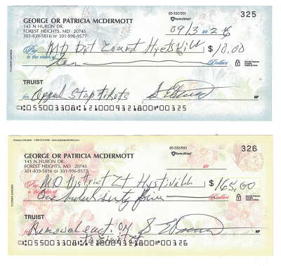

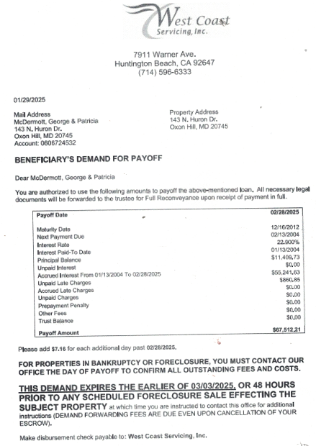
defendant corporations