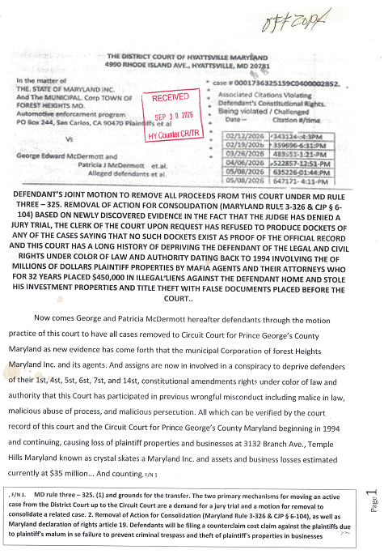2. Defendants will be proceeding pro per George Mc Dermott lead defendant also legal power of attorney for Patricia J Mc Dermott, which will be submitted to the Circuit Court for Prince George’s County, this action is necessary due to the fact that this record is never forwarded the alleged notifications of hearing sent by court agent clerk [RJ]. As court filing of 09/20/2026 was never received by USPS mail no correspondence from the court have been received, as appended [ATT-1] clearly indicates which is a correspondence to the municipal corporations chief of police September 29/2029. As a follow-up to DMV visit 09/28/2026 or the police keep refused to produce copies of the flag notices sent to the DMV against the defendants. Video was made of the before and after the before and after visit with the municipal officer chief Daniel E Ruffin who refused to take provide the information needed and requested.
3. At this time defendants submitted into the record correspondence hand-delivered to the municipal officer for the corporation. He stated there was only one outstanding flag on defendant George vehicle. And directing victim to the let’s drive safe.com website 6:30 AM 09/30/2026 indicate only one flag indicates against defendants’ vehicles. For the record defendant will be paying the citation currently noted with the DMV [ATT – 1 page 7]. Under protest that tags may be renewed while waiting for the legal process to proceed.
4. Defendants now respectfully requested the Hon. JUDGE DORSAINVIL. Now instruct the clerk of the court to file and record this official notice of removal and prepare and send all motions pleadings papers judgments and orders including any docket sheets hearing transcripts and other documents to Circuit Court clerk’s office upper Marlboro Maryland as required under(Maryland Rule’s 3-326 & CJP § 6-104), plaintiff will now set forth the attachment designations with this motion for the record.
ATT-# | Description of attachment in support of motion for removal to Circuit Court for a counterclaim cross-claim will be filed against plaintiffs | Date | Page #
ATT-1 | Defendants attempts to get proof of flags on title from municipal officer agents who would not timestamp or receive the documents see videos posted 09/27/26 through 09/30/2026@ youtube.com/@George4Justice | 09/29/26 | Pages –  3 – 4
ATT- 2 | Flag notice from DMV necessitating request on municipal officer one flag noticed will be paid under duress to preserve the record for appeal | 09/28/26 | Pages –  5 + 8
ATT-3 | Plaintiff’s motion to the court not answered as of the filing of this motion court refuses to produce a legally required docket of cases or any scheduling order as of 09/30/2026. Videos have been made of request posted at youtube.com/@George4Justice | 08/20/26 | Pages –  6 – 7
Respectfully submitted

George & Pat Mc Dermott as defendants all rights reserved UCC. 101, 102, 202, 306-08. U.S. Constitution
Certificate of service. I joined McDermott certified true copy of this motion with attachments served on the CEO of municipal Corporation trading as Forest Heights MD. To its CEO Troy Barrington Lilly By certified USPS mail at article #9589- 0710- 5270- 3288- 2505- 53. at 508 Arapahoe Drive, Forest Heights, MD 20745 on 09/30/2026 by George Mc Dermott
George E. McDermott
143 N. Huron Drive
Forest Heights, MD 20745
phone # (301) 996-9577 email
at georgemcdermid@2018@Gmail.com
September 29, 1926

Forest Heights Maryland
Police Department
Chief Daniel E. Ruffin
5508 Arapahoe Drive
Forest Heights, Maryland 20745
(301) 839-4040, Fax (301) 839-1122

Chief Daniel E. Ruffin
Dear Chief Daniel E. Ruffin . Myself and my wife who I have a legal power of attorney to deal with the matters involving flags on our vehicles due to stop sign violations and alleged speed camera violations. Which I have sent several letters to the town attorney and members of the town Council as well as this office asking for discovery for proceedings in litigated in the District Court traffic division Hyattsville Maryland. Where I have visited several times because the court refuses to set a trial date, request for discovery, and refuses to allow a jury trial. On my last visit to the court the clerk of the court informed me that there are no dockets for any of these cases where I can show as evidence that I have in good faith try to get people discovery to the motion papers filed.
1. On September 27 2026 defendants received notice that flags had been put on their title vehicles on. September 28, 2026. I visited the DMV Largo to get information on these flags see attachment [ATT – 1]. Myself and my wife now request copies of all citations flag notices issued by the corporate municipal Township. So I can prepare my motion for removal of all actions from the District Court of Maryland traffic division to the Circuit Court criminal division and demand a jury trial. Where I can protect my 1st, 4st, 5st, 6st, 7st, and 14st, constitutional amendments allowing me to face my accusers in open court. Which is currently being denied by Judge DORSASNVIL. Noncompliant order of the court. I would now respectfully request copy of all flags / notices to the DMV be produced to be used as evidence department has issued against myself and my wife vehicles as I have exhausted all remedies with your initial blow officers and supervisors failing to answer discovery requests served by certified USPS mail. F/N - 1
2. If this formal request is not to be honored, I would also request a rejection letter as to why the department did not furnish these documents and what the total outstanding cost are including all payments due as well as penalties assessed to clear up this matter. I thank you for your time and attention in this matter, no response I hope you can have your response ready by 12 PM September 30 2026 to be picked up at your office, God bless and have a wonderful day. Status notice criminal/traffic proceeding.
yours in truth George McDermott. All rights reserved UCC. 101, 102, 202, 306-08. U.S. Constitution/Bill of Rights.
F/N – 1. U.S. Constitution states. All persons born or naturalized in the United States, and subject to the jurisdiction thereof, are citizens of the United States and of the State wherein they reside. No State shall make or enforce any law which shall abridge the privileges or immunities of citizens of the United States; nor shall any State deprive any person of life, liberty, or property, without due process of law; nor deny to any person within its jurisdiction the equal protection of the laws.
ATT-# | description of attachment as proof of record supporting request | date | page #
ATT-# | Notice of flags on defendants vehicles preventing retailing | 09/28/26 | page.02
ATT-# | By email 09/25/2026 DMV has no records | 09/25/26 | Page. 03
ATT-# | Proof citations being challenged as unconstitutional no discovery | 08/20/26 | page.04
ATT-# | DMV. Has no flags must be attained by municipal authority | 09/28/26 | page.05

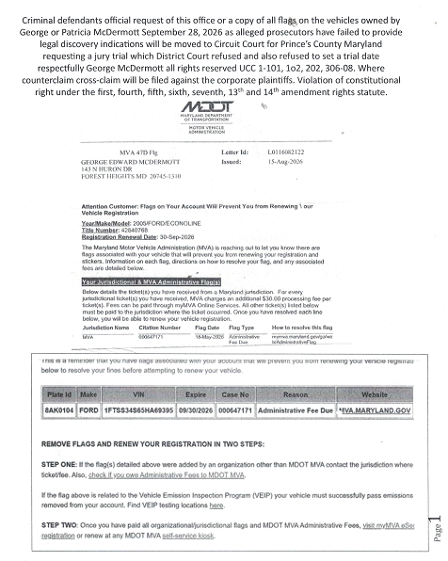
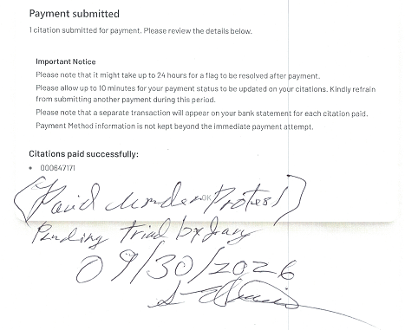
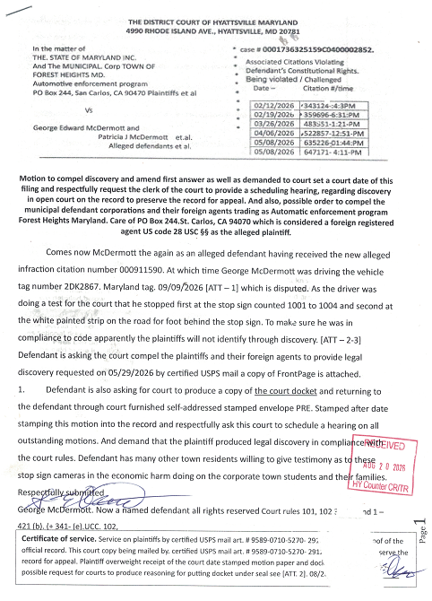
10 page motion with attachments the defendant’s have never received a hearing notice from the clerk of the court as of this regarding this filing or any others. And passive September 2026 plaintiff's art having to defend flags on their title predict preventing him from renewing their vehicle registration entitles.
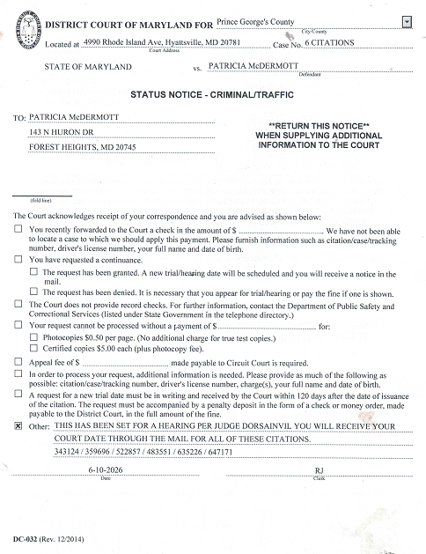

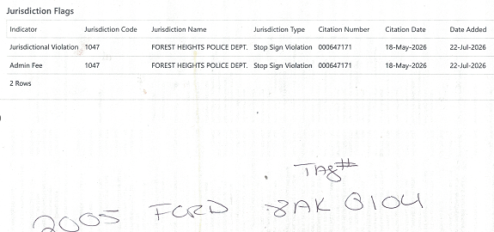
Screenshots of the website let's drive safe.com let's drive safe @7:10 AM reveal a different story not only are the citations listed here and below municipal officer stated that there are actually 10 cases against the defendants which the officer would not provide a printout of upon request see video posted at defendants https://www. youtube.com/@George4Justice
All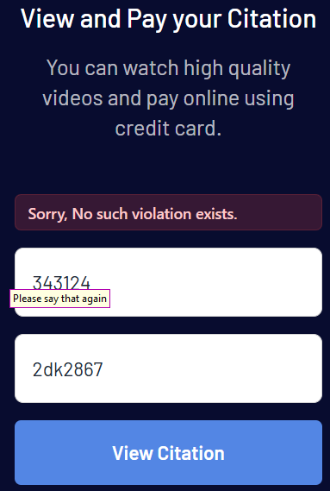 | 000647171  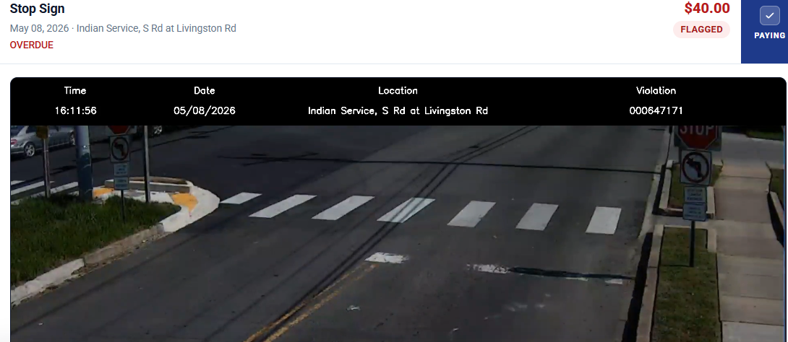 |   Forest height police chief stated stop sign cameras installed due to survey showing 933 stop sign violations from one stop sign location and community 09/29/26
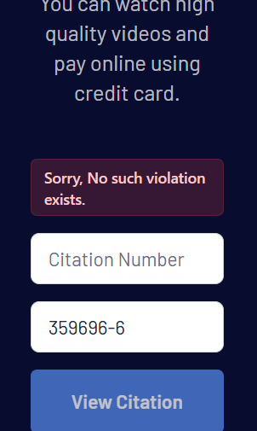 | 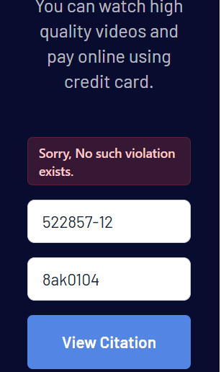
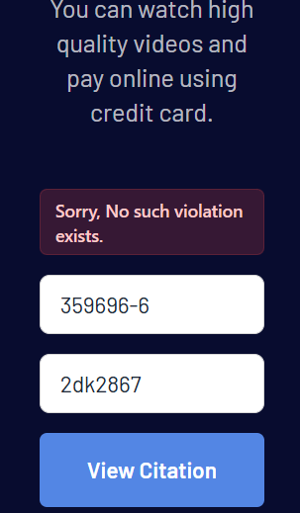 | 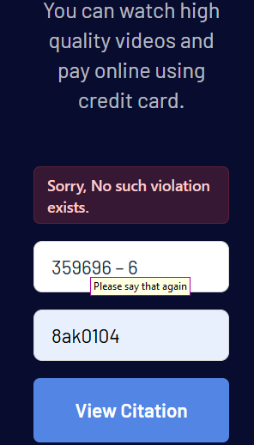
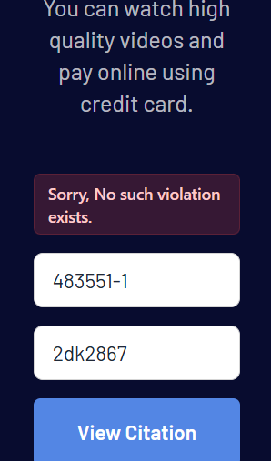 | 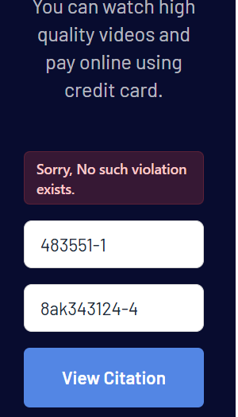
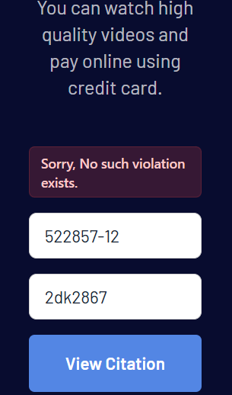 | 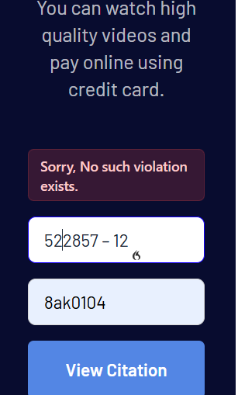
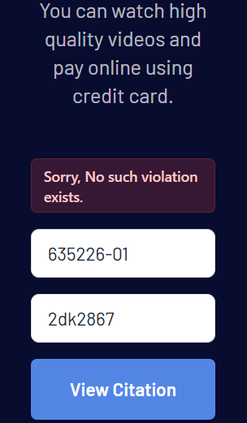 | 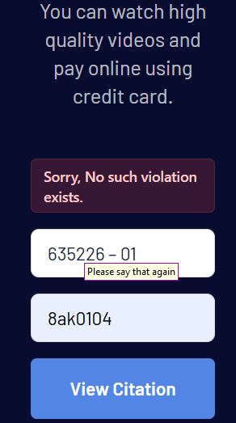
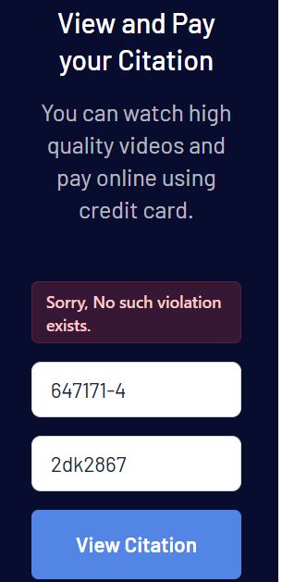 | 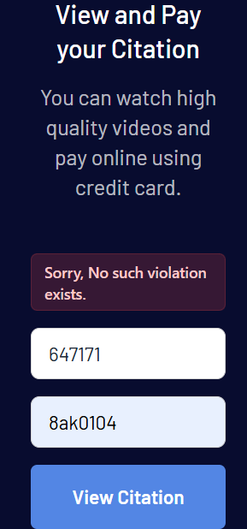
Chief Daniel E. Ruffin.
The only information the DMV office could give me was to refer me to your office seam line item 1047 stating that they had no records of the flags on my tags. They are generated by the municipal governments necessitating this filing with your office I need a copy of each of these flags notices as I am unfortunately going to have to have the case transferred from Traffic Ct., Circuit Court for Prince Georges County Maryland criminal division demanding a jury trial which the District Court has denied. And will not produce any records of.

